

Sample Design Report

Road Safety Improvement Scheme

*[INSERT TII Ref. No.]*

Date: xx/xx/20xx

Local Authority Logo & Technical Advisor Logo

Contents

1 Introduction 5

2 Collision History 5

3 Safety Objectives 5

4 Existing Conditions 5

4.1 Speed 5

4.2 Traffic Volumes 6

4.3 Horizontal Alignment 6

4.4 Vertical Alignment 6

4.5 Cross Section Crossfall & Superelevation 6

4.5.1 Cross Section 7

4.5.2 Crossfall 7

4.5.3 Superelevation 7

4.6 Junctions & Accesses 7

4.7 Facilities for Vulnerable Road Users 7

4.8 Visibility & Sightlines 7

5 Environmental, Archaeological and Other Constraints 7

5.1 Appropriate Assessment 7

5.2 Ecological Assessment 7

5.3 Other Environmental Surveys 7

5.4 Archaeological Constraints 8

6 Proposed Design 8

6.1 General 8

6.2 Land Acquisition 8

6.3 Horizontal Alignment 8

6.4 Vertical Alignment 8

6.5 Cross Section Crossfall & Superelevation. 8

6.5.1 Cross Section 8

6.5.2 Crossfall 8

6.5.3 Superelevation 9

6.6 Facilities for Vulnerable Road Users 9

6.7 Junctions & Accesses 9

6.8 Visibility and Sightlines 9

6.9 Drainage 9

6.10 Pavement 9

6.11 Safety Barrier Risk Assessment and Provision 10

6.12 Traffic Signs and Road Markings 10

6.13 Accommodation Works 10

6.14 Lighting 10

6.15 Departures from Standard 10

7 Road Safety Audit 10

8 Total Scheme Budget 10

9 Project Appraisal Balance Sheet 11

Appendix A – Design Drawings i

Appendix B –Road Safety Audit ii

Appendix C – Cost Estimate iii

Appendix D – PABS v

Appendix E - Departures from Standard vii

# Introduction

[Insert a description of the scheme, the scheme objective and previous approvals including Gateway 1 Approval]

e.g. The proposed scheme consists of the provision of a right turning lane on the N99 at the R999 junction to address a history of rear-end collisions. The scheme was identified as a Type B RSIS scheme and received Gateway Approval 1 in accordance with TII Publication GE-STY-01037 in January 2020. The preferred option in the Feasibility and Options report (Report reference XXX) has been designed in accordance with the relevant standards. This report has been prepared in accordance with DN-GEO-03030 and approval is sought to proceed to Phase 4, Statutory Procedures.

A site location map is provided below.

[INSERT LOCATION MAP]

# Collision History

[Insert details of any additional collision analysis carried out post-production of the Feasibility and Options Report, if any]

No further collision analysis has been carried out further to the production of the Feasibility and Options Report.

# Safety Objectives

[Insert safety objectives of the scheme, there may be more than one objective, always consider vulnerable road users]

The safety objectives of the scheme are as follows;

* Provide refuge for right turning vehicles on the N99 to reduce the likelihood of rear-end collisions.
* Provide safe routes for pedestrians and cyclists through the upgraded junctions
* Provide passively safe boundary fencing at the junction.

# Existing Conditions

## Speed

[Include details of speed limit and actual speed, operational speed maps may be available from TII]

The posted speed limit at this section of the N99 is 100km/hr. The operational speed of this section of the network is 105km/hr. A traffic survey was carried out and as part of that survey speed surveys were undertaken. The 85th percentile speed in the northbound carriageway was 98km/hr and the 85th percentile speed in the southbound carriageway was 103km/hr.

The speed limit on the R999 is 80km/hr. Actual speed on the R999 was not surveyed as vehicle speeds are low on approach to the junction.

## Traffic Volumes

[Insert details relating to existing traffic volumes]

A traffic survey and assessment were carried out in February 2020. [Insert report reference] The results of the survey show that the N99 mainline has an AADT of 6702. A summary of the turning movements at the junction in the am and pm peak is shown in the extract from the traffic survey below.



## Horizontal Alignment

[Include details of the horizontal alignment]

The N99 has a straight horizontal alignment. The R999 has an approximate 100m horizontal curve 150m from the junction and is straight from that curve to the junction where it joins the N99 at 90 degrees.

## Vertical Alignment

[Include details of the vertical alignment]

The N99 has a vertical crest 300m upstream of the junction. The crest curve has a Crest K Value of 120. There are vertical straight sections leading to the crest curve on both side with a gradient of 1.5%. The R999 has a constant grade of 1.5% on approach to the junction.

## Cross Section Crossfall & Superelevation

[Insert any relevant cross-sectional details, typical existing cross section details may be preproduced from the design drawings]

### Cross Section

The existing Cross section of the N99 is a single carriageway with no hard shoulders of 7.5m. There are wide verges that are overgrown. The road boundary has timber post and rail fences which bound with agricultural land. The cross section of the R999 is a single carriageway of 7.0m with no hard shoulders.

### Crossfall

[Insert details relating to crossfall]

There is normal crossfall (2.5%) from the centreline of both the N99 and the R999 on approach to the junction.

### Superelevation

[Insert details relating to superelevation]

Not Applicable.

## Junctions & Accesses

R999 Junction discussed in entire report not this section alone.

## Facilities for Vulnerable Road Users

[Describe existing facilities for vulnerable road users]

This is a rural section of the N99, there are currently no dedicated facilities for pedestrians or cyclists. Pedestrians have to walk in the carriageway as there is no hard shoulder and the verge is uneven and overgrown with vegetation.

## Visibility & Sightlines

[Insert details relating to visibility and sightlines]

Visibility for a driver exiting from the R999 is restricted due to the vegetation growth in the verge.

# Environmental, Archaeological and Other Constraints

## Appropriate Assessment

[Insert details of Appropriate Assessment carried out, it is not necessary to append the entire reports however pertinent information leading to design constraints should be included.]

A report for the purposes of Appropriate Assessment Screening was carried out for the Project by [insert entity and report reference]. It was the view of the Author that it was not necessary to undertake any further stage of the Appropriate Assessment process.

## Ecological Assessment

An ecological assessment was carried out on the overgrown verges. Although some evidence of habitat was established it was concluded that there would be no significant effects associated with clearing the verge to improve sightlines.

## Other Environmental Surveys

[Insert details of any other environmental surveys e.g. mammal surveys, fish surveys, bird surveys agronomy assessments etc.]

Not Applicable.

## Archaeological Constraints

Not Applicable. The TII Project Archaeologist carried out a desktop review and concluded that the propose works would were being carried out in an area that was subject to recent (when the N99 was being upgraded in 2001) disturbance and would not require any additional monitoring or investigation.

# Proposed Design

## General

[Provide a general description of the proposed design]

The right turning lane has been designed in accordance with TII Publications DN-GEO-03060 for a design speed of 100km/hr. There is no requirement for land acquisition as the scheme can be provided within the existing road boundaries.

## Land Acquisition

Not Applicable.

## Horizontal Alignment

[Description of the range of horizontal curvature etc and highlighting any elements that feature in Departures from Standards]

Th horizontal alignment follows the existing centreline of the N99 the right turning lane has been provided by widening about the centreline. The N99 is a straight alignment. To the south is a large radius right hand bend (R1220 approx., recreated from a topographical survey) and to the north is a large radius left hand bend (R1310 approx.). See Drawing N99-DR-01 Rev 02.

## Vertical Alignment

[Description of the range of vertical curvature etc and highlighting any elements that feature in Departures from Standards]

The vertical alignment will broadly match the existing vertical alignments of both the N99 and R999. The junction will be raised slightly to accommodate drainage and a shift in the crown line location on the N99. See Drawing N99-DR-02 Rev 02.

## Cross Section Crossfall & Superelevation.

### Cross Section

[Describe the cross section(s) and provide typical cross section details from the design drawings, describe any changes in the cross sections from the standard construction details]

The cross section is to be 3 x 3.5m (2x through lane and 1 no turning lane) lanes with a hard shoulder width of 1.5m through the junction.

### Crossfall

[Provide a description of proposed crossfalls]

The crown line on the N99 will be changed to the joint between the southbound lane and the proposed right turning lane. As a result, the southbound edge of pavement will have a higher finished level than the existing level.

### Superelevation

[Describe any superelevation]

Not Applicable.

## Facilities for Vulnerable Road Users

[Describe proposed facilities for vulnerable road users]

None

## Junctions & Accesses

[Provide details of each junction and access along the scheme]

The proposed junction is to be a ghost island junction with a channelising island in the R999. The junction is cited on a non-overtaking section of the N99. The circular corner radius is to be 13m as the Regional road attracts a significant number of HGVs.

The taper for the Ghost island is to be 1:30, the deceleration length is to be 80m and the turning lane width is to be 3.5m

## Visibility and Sightlines

[Provide a description on visibility and sightlines achieved]

Site clearance of the vegetation in the verge will take place to the road boundaries. This will provide a visibility envelope of 3.0m x 215m including to the high object of 1.05 which meets the requirements of Table 5.5 and Table 5.4 of DN-GEO-03060.

The N99 has a relatively straight alignment and the full stopping sight distance is achieved.

## Drainage

[Provide description of road and other drainage features including any approval sought to be sought during Phase 4]

It is proposed to relocate the existing filter drain on the N99 to the rear of the new pavement. At the junction kerbs and gullies will be provided. The gullies will connect to a carrier drain (225mm dia. Pipe) that will connect with the existing chamber in the eastern verge of the R999. The capacity of the existing drainage system was checked and there is sufficient capacity to cater for the extra quantities of surface water associated with the wide paved area.

## Pavement

[Pavement details to be provided including summary of pavement design]

A site investigation was carried out to determine the existing pavement depth. The existing N99 was constructed in 2001 and consists of 150mm Cl 804, 140mm base course, 80mm binder course and 45mm Hot rolled asphalt surfacing. It was agreed to carry out widening based on the same construction. The surfacing course will be planed and replaced over the entire length of the scheme with some regulating course provided to cater for the change in crown line.

The same construction will be provided on the R999.

A capping layer of 300mm will be provided in the widened areas. The site investigation included a number of trail pits in the existing verges which showed a CBR of 5% at the formation level.

## Safety Barrier Risk Assessment and Provision

[Include Risk Assessment as per Chapter 5 of DN-REQ-03079 if required.]

The existing wide verges are to be cleared and the boundary post and rail fences to be replaced with post and tensioned mesh fencing in accordance with standard detail CC-SCD-00320. There will therefore be no hazards within the Clear Zone. A formal vehicle restraint risk assessment has not therefore been carried out.

## Traffic Signs and Road Markings

[Include details of proposed signs]

It is proposed to replace the existing directional signage including advance directional signage with passively safe signs.

## Accommodation Works

[Include details of proposed accommodation]

The existing field gate on the R999 is to be replaced with a new gate set back 8.0m from the carriageway edge. The hard-standing area in front of the gate is to be provided with a double surface dressing in accordance with CC-SCD-02754 & CC-STD-00706

## Lighting

[Include details of proposals for the provision or removal of lighting]

Not Applicable, no lighting at existing junction and no lighting is proposed.

## Departures from Standard

Not Applicable.

# Road Safety Audit

[Summary discussion only required here, final signed report to be contained in an Appendix to this report.]

A Combined Stage 1&2 Road Safety Audit was carried out in March 2020. The final, signed report is provided in Appendix B. Three problems were identified by the Audit Team. Two of the problems related to signage and the third related to road markings. All recommendations were accepted by the Design Team and are incorporated into the design drawings appended to this report. The final audit report has been uploaded to the RSAAS.

# Total Scheme Budget

[the cost estimate from the Feasibility and options report is to be stated along with the revised cost estimate, and a summary of the reasons for changes if any. A detailed breakdown to be provided in an Appendix to this report]

The cost estimate for the scheme in the Feasibility and Options Report approved at Gateway 1 was €750,000 including VAT. An updated cost estimate has been prepared and a breakdown of the estimate is provided in Appendix C of this report.

The current cost estimate is €762,000 including VAT which represents a 1.6% increase. The increase is not due to a change of scope however it is believed to be more accurate due to the additional detail and information available at this stage.

# Project Appraisal Balance Sheet

[PABS to be contained in an Appendix to this report]

A project appraisal balance sheet has been prepared for this scheme in accordance with the guidance set out in DN-GEO-03030. The PABS is provided in Appendix D. The overall description of the scheme is neutral.

# Appendix A – Design Drawings

# Appendix B –Road Safety Audit

# Appendix C – Cost Estimate

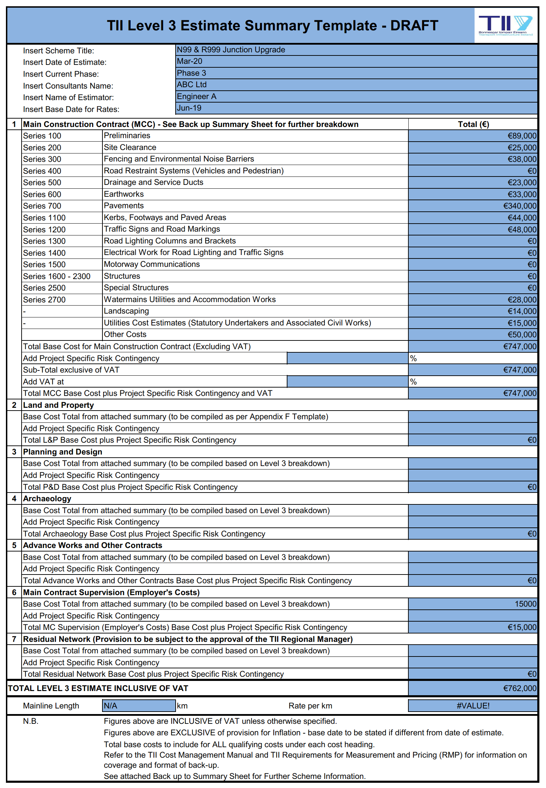

**[Please see TII Publications at** [**https://www.tiipublications.ie/downloads/**](https://www.tiipublications.ie/downloads/) **for work sheets** [**PE-PAG-02021_Unit-6.2-Attachments.zip**](https://www.tiipublications.ie/downloads/project_appraisal_guidelines/PE-PAG-02021_Unit-6.2-Attachments.zip) **that maybe used.]**

# Appendix D – PABS

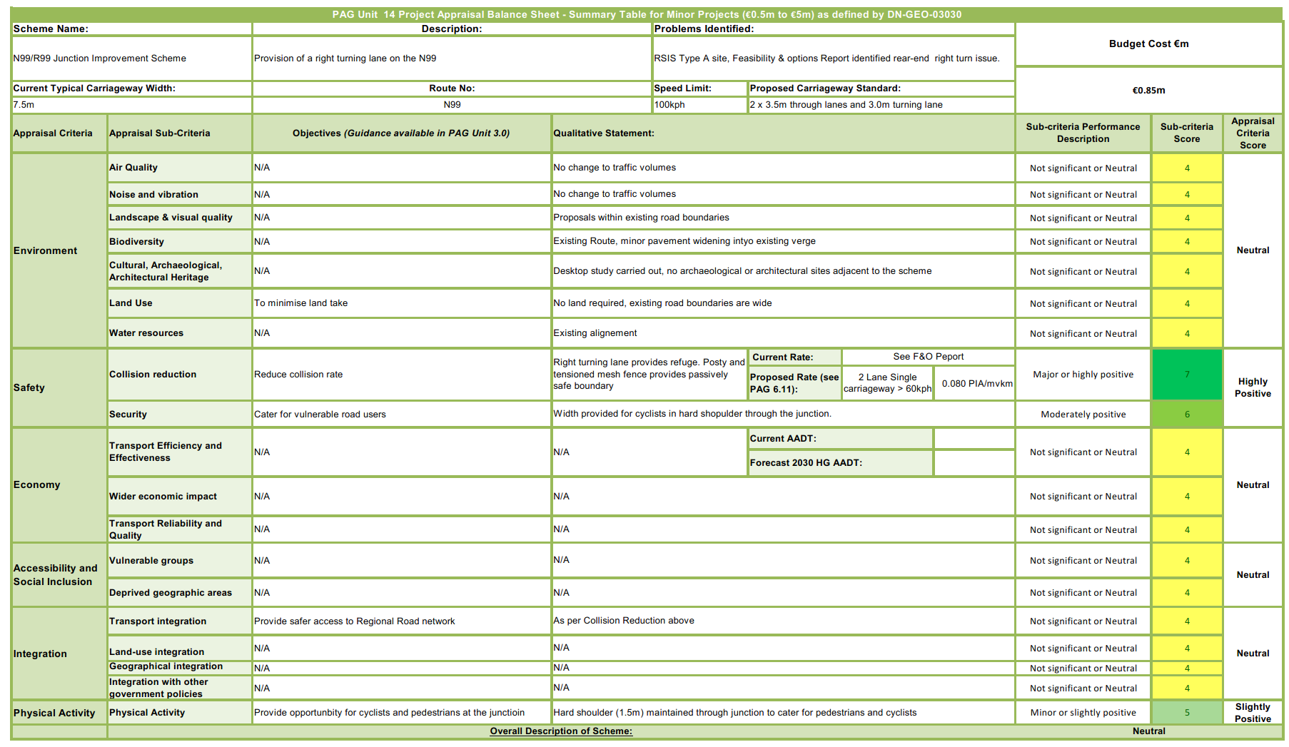

# Appendix E - Departures from Standard

