.

Appendix N -
Pre-Appointment BIM Execution Plan Template
June 2026

Contents
1. Guidance on using this Template 1
2. Scope and Purpose 2
2.1 Documents Relationship 2
3. Information Management Function 4
3.1 Project Overview 4
3.2 Project Information 4
3.3 Organisation Structure and Commercial Relationship of the Delivery Team 4
3.4 Delivery Team 5
4. Information Delivery Strategy 6
4.1 Approach to meeting the Appointing Party’s Exchange Information Requirements. 6
4.2 CDE and Collaboration 6
4.3 Design assurance, Coordination process and Clash Detection 6
4.4 Federation Strategy 6
4.5 Level of Information Need 6
4.6 Health and Safety Management 6
4.7 Geospatial Information Systems (GIS) Implementation 7
4.8 4D and Digital Rehearsals 7
4.9 5D Process 7
4.10 Carbon management 7
4.11 Training and Competence 7
5. Production and Exchange of Information 8
5.1 Information Exchange Formats 8
5.2 Nomenclature 8
5.3 Production, review, approval and authorisation of information. 8
6. Information Management Assignment Matrix 9
7. Information Security 12
8. Cyber Security 13
9. Mobilisation Plan 14
10. Capability and Capacity Assessment 15
11. Project Reference Information 16
Appendix A - Acronyms and Abbreviations 17

Guidance on using this Template
This Pre-Appointment BIM Execution Plan (BEP) Template should be used and completed by the relevant Tenderer who should submit it to the Appointing Party as part of the Tender Submission.
The Pre-Appointment BEP is a delivery plan and should provide details on how the Tenderers will collaboratively produce, share and manage relevant Information requirements associated with their works.
This template has been provided so that there is a standard response from each of the Tenderers on the program of works and the Appendix L of the GE-BIM-00101 - Exchange Information Requirements.
Any sections marked in blue or [Insert Here] is for the Tenderer to input or complete.
Any sections in Green are guidance for completing the form – please delete prior to submission.
Remove the highlighting prior to completing the document and delete this guidance section.
Should a Tenderer wish to supplement this template, ensure that original structure is maintained:
- New sections should be added after the last original section.
- New sub-sections should be added after the last original sub-section.
- New columns in a table should be added to the Right.
- New rows in a table should be added beneath.

Scope and Purpose
The purpose of this Pre-Appointment BEP is to define the methods and procedures to deliver the full suite of Exchange Information Requirements (EIR). This template provides a structure to develop the Pre-Appointment BEP in alignment with the I.S. EN ISO 19650.
The Pre-Appointment BEP will include:
- Details of individuals undertaking the information management function
- The proposed information delivery strategy
- The proposed federation strategy to be adopted by the delivery team
- The delivery team’s assignment matrix
- Proposed additions/amendments to project’s information production methods and procedures
- Proposed additions/amendments to project’s information standard
- Proposed schedule of software, hardware and IT infrastructure
- Provide a response on the adherence and delivery of the requirements
- Mobilisation plan
[Insert Here]
If there are any further use cases and goals from the organisations or project, then please add below.

Documents Relationship
The document shall comply with the EIR and other relevant documents as shown in Figure 2.1. For the full list of applicable documents refer to the GE-BIM-00101 – BIM for Infrastructure Implementation Guidelines for National Roads section 1.4.
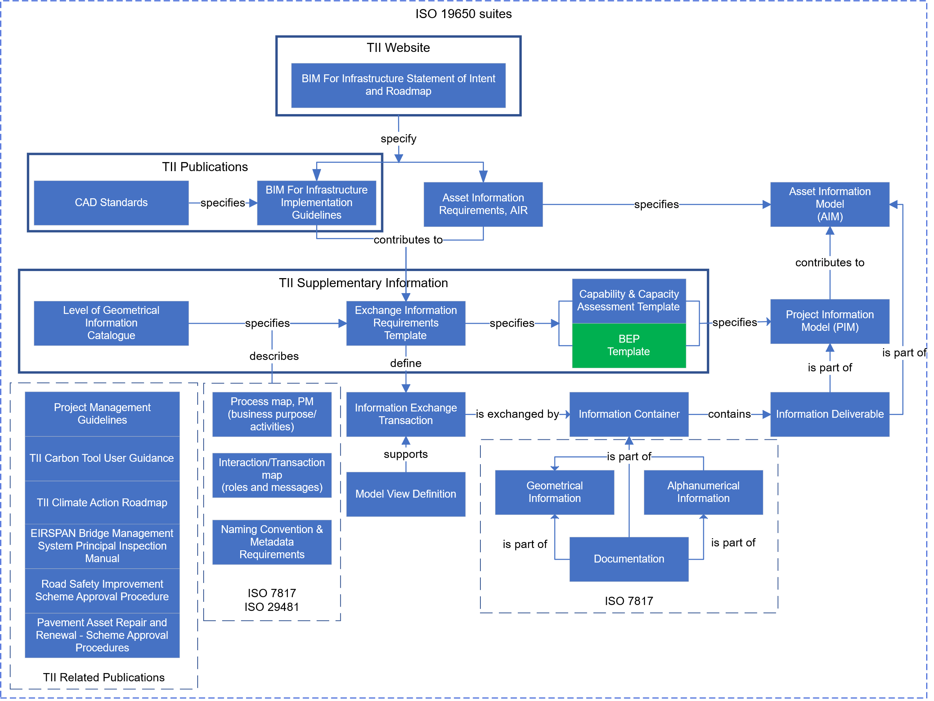
Figure 2.1 – Documents Relationship

Information Management Function

Project Overview
[Provide a brief outline of the project and the desired outcomes of the Appointing Party]

Project Information
Table 3.1 – Key project information
Information Required | Details
Project Name | [Insert Here]
Project Address | [Insert Here]
Project Number (Appointing party Reference) | [Insert Here]
Description (works) | [Insert Here]
Appointing Party (Client) | [Insert Here]
Appointing Party Information Manager | [Insert Here]
Lead Appointed Party (LAP) | [Insert Here]
LAP Information Manager | [Insert Here]
Appointed Party(ies) | [Insert Here]
Survey Grid | [Insert Here]
Form of Appointment | [Insert Here]
Project Stage Commencement | [Insert Here]
[Insert Here] | [Insert Here]

Organisation Structure and Commercial Relationship of the Delivery Team
Provide information in the table below and an organisational chart / diagram. The forms of contract (NEC option C for example) should be captured. If these are unknown, then TBC is acceptable.

Table 3.2 – Organisational Structure
Organisation Name | Scheme Role (Lead Appointed Party/Third Party/Appointed Party) | Project Role | Form of Contract
[Insert Here] | [Insert Here] | [Insert Here] | [Insert Here]
[Insert Here] | [Insert Here] | [Insert Here] | [Insert Here]

Delivery Team
Provide information in the table below of the split of the delivery team into task teams. Where the task information management function may transfer during the life of the project, please add an additional column identifying which Work Stage each team delivers the task information management function for. Add additional rows for task teams and people.
Table 3.3 – Delivery Team
Function | Task Team (Discipline) | Organisation | Name | Email Address
Project Information Manager | Information Management | [Insert Here] | [Insert Here] | [Insert Here]
Project Manager | Project Management | [Insert Here] | [Insert Here] | [Insert Here]
[Insert Here] | [Insert Here] | [Insert Here] | [Insert Here] | [Insert Here]

Information Delivery Strategy

Approach to meeting the Appointing Party’s Exchange Information Requirements.
Describe an approach to meeting the Client’s Exchange Information Requirements and IM goals.
[Insert Here]

CDE and Collaboration
Describe process for the collaborative production of information flow and proposed systems.
Explain how information will be delivered to Appointing Party.
[Insert Here]

Design assurance, Coordination process and Clash Detection
Provide details on the co-ordination process for clash detection and issue management, and approval processes for the design assurance.
[Insert Here]

Federation Strategy
Explain how discipline models will be combined into federated information models to support coordination, review, and information delivery.
[Insert Here]

Level of Information Need
Provide details in this section of compliance and application of the LOIN guidance and standards.
Provide information on the LOIN throughout the project stages and highlight areas where the LOIN will be increased / decreased relative to the minimum requirements outlined in the EIR.
[Insert Here]

Health and Safety Management
Provide details on the H&S approach and how Information Management will support this. Include information about tools and proposed software to manage H&S risks and how they will comply with the data requirements as part of the EIR.
[Insert Here]

Geospatial Information Systems (GIS) Implementation
If applicable include details on how GIS will be adopted and used on the project. Include roles, technology and how deliverables will be generated and leveraged.
[Insert Here]

4D and Digital Rehearsals
If specified by the Exchange Information Requirements (EIR) provide details on the 4D implementation. Include diagrams, roles, workflows, outputs, technology and benefits as required.
[Insert Here]

5D Process
If specified by the Exchange Information Requirements (EIR) details on the 5D implementation. Include diagrams, roles, workflows, outputs, technology and benefits as required.
[Insert Here]

Carbon management
Provide details on the carbon management approach and how Information Management will support this. Include tools and proposed software to manage carbon data, and how they will comply with the data requirements as part of the EIR.
[Insert Here]

Training and Competence

Competence
Provide details on the competence of the project delivery teams staff to perform information management function and tasks by completing Capability and Capacity Assessment Template.

Training
For training, please include training requirements that shall be delivered as part of the works to the project staff.
[Insert Here]

Production and Exchange of Information

Information Exchange Formats
The exchange of information will be in the formats specified below (Table 5.1).
Table 5.1 – Exchange Formats
Information Type | Native Format | Exchange Format
Information / 3D Models | [Insert Here] | [Insert Here]
Federated Models | [Insert Here] | [Insert Here]
2D CAD (authoring) | [Insert Here] | [Insert Here]
Drawings | [Insert Here] | [Insert Here]
Documents | [Insert Here] | [Insert Here]
GIS Data | [Insert Here] | [Insert Here]
Point Cloud | [Insert Here] | [Insert Here]
Aerial Imagery | [Insert Here] | [Insert Here]
Imagery | [Insert Here] | [Insert Here]
Semi Structured Data  e.g. Labour allocations with associated cost data | [Insert Here] | [Insert Here]
Presentations | [Insert Here] | [Insert Here]
Video Files | [Insert Here] | [Insert Here]
Alignment File | [Insert Here] | [Insert Here]
Terrain Data | [Insert Here] | [Insert Here]

Nomenclature
Provide details on how the naming of containers and metadata will be applied across the project and implemented in systems. Please include few examples.
[Insert Here]

Production, review, approval and authorisation of information.
Provide details on how procedures outlined in I.S. EN ISO 19650-1:2018 Section 12 will be applied.
[Insert Here]

Information Management Assignment Matrix
If the Information Management Assignment Matrix is not provided within the Exchange Information Requirements (EIR), the lead appointed party should complete the table below to define the allocation of information management responsibilities for the project. The Table 6.1 is pre-populated with typical responsibilities aligned with ISO 19650 information management processes. These should be reviewed and adjusted to reflect the project-specific roles, organisational structure, and contractual responsibilities within the delivery team
Please complete the table below.
Table 6.1 – Responsibility Matrix (Source: ISO 19650-2 Annex A)
Key  R – Responsible for undertaking activity  A – Accountable for activity completion  C – Consulted during activity  I – Informed following activity completion |  | Appointing party | Third party | Lead appointed party | Appointed party
ISO 19650-2 Task
5.1, 5.2 Assessment, need and Invitation to Tender
5.1.4 | Establish the project’s information standard | A/R | I | I | I
5.1.7 | Establish the project's common data environment | A/R | I | I | I
5.1.8 | Establish the project's information protocol | A/R | I | I | I
5.2.4 | Compile invitation to tender information | A/R | I | I | I
5.3 Tender Response
5.3.1 | Nominate individuals to undertake the information management function | I | A/R | A/R | A/R
5.3.2 | Establish the delivery team's (pre-appointment) Information Execution Plan | I | C | A/R | C
5.3.3 | Assess each task team’s capability and capacity | I | C | A/R | C
5.3.4 | Establish the delivery team's capability and capacity | I | C | A/R | C
5.3.5 | Establish the delivery team’s mobilization plan | I | C | A/R | C
5.3.6 | Establish the delivery team’s risk register | I | C | A/R | C
5.3.7 | Compile the delivery team's tender response | I | C | A/R | C
5.4 Appointment
5.4.1 | Confirm the delivery team's BIM execution plan | I | C | A/R | C
5.4.2 | Establish the delivery team’s detailed responsibility matrix | I | C | A/R | C
5.4.3 | Establish the lead appointed party’s exchange information requirements | I | I | A/R | I
5.4.4 | Establish the task information delivery plan(s) | I | C | A/R | C
5.4.5 | Establish the master information delivery plan | I | I | A/R | I
5.4.6 | Complete lead appointed party’s appointment  documents | I | I | A/R | I
5.4.7 | Complete appointed party’s appointment  documents | I | A/R | I | A/R
5.5 Mobilisation
5.5.1 | Mobilize resources | C | C | A/R | C
5.5.2 | Mobilize information technology | C | C | A/R | C
5.5.3 | Test the project’s information production methods and procedures | C | C | A/R | C
5.6 Collaborative Production of Information
5.6.1 | Check availability of reference information  and shared resources | C | C | A/R | C
5.6.2 | Generate information | I | A/R | A/R | A/R
5.6.3 | Undertake quality assurance check | I | A/R | A/R | A/R
5.6.4 | Review information and approve for sharing | I | A/R | A/R | A/R
5.6.5 | Information model review | I | I | A/R | I
5.7 Information Model Delivery
5.7.1 | Submit information model for lead appointed  party authorisation | I | A/R | I | A/R
5.7.2 | Review and authorize the information model | I | I | A/R | I
5.7.3 | Submit information model for appointing  party acceptance | I | I | A/R | I
5.7.4 | Review and accept the information model | A/R | I | I | I
5.8 Project Close-out
5.8.1 | Archive the project information model | A/R | C | C | C
5.8.2 | Capture lessons learned for future projects | A/R | A/R | A/R | A/R
ISO 19650-5
4.2 | Determine the range of security risks | C | I | A/R | I
4.7 and 4.8 | Undertake the security triage process and record the outcome | C | C | A/R | C
6 | Develop and maintain a security strategy (If required) | C | C | A/R | C
7 | Develop and maintain a security management plan (If required) | C | C | A/R | C

Information Security
Include details on how the security requirements will be implemented.
[Insert Here]

Cyber Security
This section is optional. If there are other documents that cover Cyber Security that have been/will be submitted, then this section can be left blank.
If adherence to Cyber and associated cyber policies is not covered anywhere else, then please detail compliance in this section.
[Insert Here]

Mobilisation Plan
Plan which summarises team-wide approach, responsibilities and required timescales in relation to the information management.
Note 1: Can be a standalone document or an appendix to the pre-appointment BEP.
[Insert Here]

Capability and Capacity Assessment
The template is available Appendix M of GE-BIM-00101 Capability and Capacity Assessment Template.
[Insert Here]

Project Reference Information
Optional this section can be used for the projects to reference internal templates, resource files etc for their project teams use. Suggestion is that it is contained in tables and hyperlinks provided.
[Insert Here]

- Acronyms and Abbreviations

Please add any other relevant terminology in the table below if it is referenced in the response.
Acronym | Definition
AIM | Asset Information Model  Set of structured and unstructured Information Containers relating to the operational phase of a project.
AIR | Asset Information Requirements  This defines the information that is required, and the managerial and technical aspects of producing this information, for the operation of an asset to meet the OIR.
Alphanumerical Information Containers | Information Containers holding non-graphical content that can be expressed using characters, digits and symbols, or tokens such as mathematical symbols and punctuation marks, and are normally structured in a tabular/matrix format. These are mainly used to record relevant attributes/data associated with infrastructure assets.
AR | Augmented reality  A technology that superimposes a computer-generated image on a user's view of the real world, thus providing a composite view.
BEP | BIM Execution Plan  Plan that explains how the information management aspects of the Appointment will be carried out by the Delivery Team.  NOTE 1: A pre-appointment BIM Execution Plan focuses on the delivery team's proposed approach to information management and their capability and capacity to manage information.  NOTE 2: A post-appointment BIM Execution Plan is the contractual, document, produced after appointment that confirms exactly how the Delivery Team will implement information management to meet the Appointment requirements.  NOTE 3: Specific terminology can be applied to contracts, for example the equivalent term for 'BIM execution plan' under NEC 4 terminology is the 'Information Execution Plan (IEP)'.
BIM | Building Information Modelling  Use of a shared digital representation of a built asset to facilitate planning, design, construction and operation processes to form a reliable basis for decisions.
BIP | BIM Implementation Plan  Strategic roadmap for how an organisation or company may adopt and utilise Information Management within and across different project phases
CDE | Common Data Environment  A combination of process workflows and technical solutions used to collect, manage and disseminate structured and unstructured information (information containers) for a project or asset. The CDE workflow defines the processes, and the CDE solutions are the technologies that enable those processes, with appropriate access, control, status/metadata and auditability.

Acronym | Definition
 | Used in combination with a digital storage solution, information is shared collaboratively in a logical and accessible way to help all key parties readily gain access to information, use consistent naming conventions, avoid duplication and retain ownership.
Clash Avoidance | Process of proactively preventing spatial coordination overlaps and interface issues associated with the Design, employing robust interdisciplinary collaboration techniques. This process is applied prior to Clash Detection.
Clash Detection | Process of identifying if elements of the Design are over overlapping both spatially and chronologically, and if so, where and how these interferences occur. Modern software offers tools to automate this process.
Contract | Is a legally binding agreement between two or more parties that creates enforceable rights and obligations.
CWMF | Capital Works Management Framework  Is a structure that has been developed to deliver the Republic of Ireland Government’s objectives in relation to public sector construction procurement reform. It consists of a suite of best practice guidance, standard contracts and generic template documents that form the four pillars that support the Framework
DBP | Digital Build Project  Project led by Technological University Dublin (TU Dublin) to unite all construction and built environment stakeholders to drive integrated, interoperable digital data adoption across the industry to innovatively improve efficiency, productivity, and international competitiveness on a sustainable basis in Ireland.
EIR | Exchange Information Requirements  A documented set of managerial, commercial and technical requirements for the production and exchange of project information. EIR defines the information to be delivered, the standards, methods and procedures to be applied by the delivery team and relevant project stage trigger milestones.
3D Exchange Models | Geometrical Models containing 3D representations of the scheme’s assets, divided as per an agreed breakdown structure.  The main objective of 3D Exchange Models is to facilitate the exchange and sharing of geometrical asset information between project team members and other project’s stakeholders.  They are normally supplied in open data formats and/or industry- wide proprietary formats to minimise interoperability issues and reduce risks associated with obsolescence.
FIDIC | International Federation of Consulting Engineers  An international standards organisation for construction technology and consulting engineering. The organisation is best known for the FIDIC suite of contract templates.
Geographical Information System (GIS) | Framework comprising computer-based tools and applications that provides the ability to capture and analyse spatial and geographic data.
Geometrical Models | Information Containers used to represent physical infrastructure assets, comprising information expressed using shape, size, dimension, and location.
ICMS | International Cost Management Standard  International standards for benchmarking, measuring and reporting construction project costs
IFC | Industry Foundation Class  Open data format
IM | Information Management  The function and associated activities used to define information requirements, plan and control information production, and manage the delivery and checking of information to meet the needs of a project or asset.
IMI | Information Management Initiative  Led by the Construction Leadership Council (CLC) the initiative aspires to become an industry-led and government-supported programme to progressively transform information management practices across the built and natural environment sector [1]
Information Container | Named persistent set of information retrievable from within a file, system or application storage hierarchy. Information Containers can comprise directories, folders, files, layers and symbols.
Information Exchange | Information delivered to the Appointing party at a pre-defined milestone/point in the project, which satisfies the EIR.
Information Management Deliverables | Resources, documentation and content prepared to support the effective management of information in a project in accordance with the I.S. EN ISO 19650 series.
IT | Information technology  Refers to the systems, infrastructure, and tools used to support the creation, management, exchange, and delivery of digital information throughout a built asset’s lifecycle.
JCT | The Joint Contracts Tribunal  Standard forms of contract for construction.
Level of Geometrical Information | Description of graphical content for Geometrical Models.
Level of Alphanumerical Information | Description of non-graphical content for Geometrical Models and Alphanumerical Information Containers.
Level of Information for Documentation | Description of the content for project documentation such as drawings, text documents, schedules and photos.
MIDP | Master Information Delivery Plan  Plan incorporating all relevant Task Information Delivery Plans (TIDP).
Mobilisation Plan | Plan that details the approach, timescales and responsibilities for the configuration and deployment of the necessary infrastructure and resources associated with the production and delivery of the Project Information.
NPSA | National Protective Security Authority
OGP | Office of Government Procurement  Plays a leading role in public procurement reform as part of the Department of Public Expenditure, Infrastructure, Public Service Reform and Digitalisation.
OIR | Organisational Information Requirements  This specifies what information is required to achieve an organisations strategic objectives in relation to business operation, asset management, portfolio planning etc. The OIR may be developed from an ISO 55001 asset management system.
PIM | Project Information Model  Composite information model created from separate Geometrical Models. It can embed, or be linked to, non-graphical data of modelled assets.  Note: In the context of this document Federated Model and PIM has the same meaning.
PIR | Project Information Requirements  This specifies the information that is required related to a specific project consisting of the relevant information from the OIRs and AIRs.
Project Information | Information produced and managed during the project delivery phase (including geometrical information, alphanumerical information and documentation) and controlled through the CDE;
PWCF | Public Works Contract Form(s) as published by the OGP.
RIAI | The Royal Institute of the Architects of Ireland
Security Management Plan | A plan that outlines the security requirements, threat assessments, risk mitigations and security controls necessary to protect information assets throughout the asset lifecycle in accordance with I.S.EN ISO 19650-5.
Scope | The defined boundary of work and deliverables that a party is required to provide under an agreement. It describes what is included and what is excluded, together with the outputs, quality/acceptance criteria, assumptions and constraints, interfaces, and any responsibilities needed to achieve the intended outcomes.
Task Team | A person or group of people performing a specific task – for example the drainage team or the subcontractor who is designing/constructing the vehicle restraint systems.
TIDP | Task Information Delivery Plan  Schedule of Information Containers and delivery dates, for a specific Task Team.
TII | Transport Infrastructure Ireland  Is a state agency in Ireland, dealing with road and public transport infrastructure.
Uniclass | Uniclass 2015 is a unified classification system for the construction industry covering all sectors of the industry. There are tables for civil and infrastructure projects covering road and rail, power and water. For the building sector there are tables including codes for university campuses, hospitals, schools, residential and office buildings. The codes are also there to cover landscape, structure and building services.
[Insert Here] | [Insert Here]

