Appendix B
Sample Feasibility and Options Report for Road Safety Improvement Scheme



Local Authority Logo
Date: 01/01/2020
(Type: A / B / C / D)
[INSERT TII Ref. No.]
Feasibility and Options Report
[INSERT Scheme Name]

Contents
1 Introduction 5
2 Description of the Safety Problem and Collision History 5
2.1 Identification of Problem & Objective 5
2.2 Constraints 5
2.3 Future Development / Scheme 5
3 Proposed Options 6
3.1 Options Considered 6
3.2 Option 1 6
3.3 Option 2 6
3.4 Option 3 7
4 Preferred Option 9
4.1 Evaluation of Options 9
4.2 Collision Modification Factor 9
4.3 First Year Rate of Return Based on Collision History 9
5 Programme 10
6 Conclusions and Recommendation 10
Appendix A – Sample Cost Estimate i
Appendix B – TII High Collision Locations / Road Safety Inspections iii
Appendix C - Drawings iv

Introduction
[Insert a description of the scheme, the scheme objective and justification for the scheme]
e.g. The proposed scheme has been assessed under the GE-STY-01022 Review of TII High Collision Locations and is identified as a site having a collision rate threshold of twice the average for National roads therefore needing further assessment of collisions to identify if there is a treatable Engineering solution. This report provides the options considered and the preferred option including a programme for implementation.

[INSERT LOCATION MAP]

Description of the Safety Problem and Collision History

Identification of Problem & Objective
[XX County Council assessment of the existing site, collision data evaluation and other data.]
[Review of the HCL or RSI and site visit etc. ]
[Summary of road safety problem and scheme objective.]

Constraints

[List any project/design constraints if applicable (e.g. Land Acquisition, Utilities Diversions, Environmental, IAPS, Vulnerable Road Users/existing geometry etc. )]
[N/A if no constraints]

Future Development / Scheme
[Please state if there are Pavement Schemes or Minor/Major Schemes planned at the location (e.g. Route Realignment, Bypass, Pavement Schemes, Signing and Lining etc.)]
[N/A if no Schemes]

Proposed Options

Options Considered
[This section presents the Concept Design for each option considered]

Option 1
[e.g. Do-Nothing / Do-Minimum / Short-term/ Do-something]
[INSERT Option Illustration]
[Sample estimated costs]
Description | Cost/€ | Total Estimate (ex VAT)
Series 200 Site Clearance | 5,000 | € 49,000
Series 1200 - signs | 16,000 | € 49,000
Series 1200 - markings | 15,000 | € 49,000
Junction radii improvements | 10,000 | € 49,000
Planning and Design (incl.GI & Topo) if applicable | - | € 49,000
Road Safety Audit (estimate) | 3,000 | € 49,000
Archaeology ( if applicable) | - | € 49,000
Land and Property ( if applicable) | - | € 49,000
Other costs (as applicable to scheme scope or complexity) | - | € 49,000

Option 2
[e.g. Do-something/Medium-Term]
[INSERT Option Illustration]
[Sample estimated costs]
Description | Cost/€ | Total Estimate (ex VAT)
Series 100 Preliminaries | 80,000 | € 1, 465,000
Series 200 Site Clearance | 25,000 | € 1, 465,000
Series 300 Fencing | 100,000 | € 1, 465,000
Series 400 Safety Barrier | 25,000 | € 1, 465,000
Series 500 Drainage | 250,000 | € 1, 465,000
Series 600 Earthworks | 150,000 | € 1, 465,000
Series 700 Pavement | 600,000 | € 1, 465,000
Series 1100 Kerbs Footways and Paved Areas | 45,000 | € 1, 465,000
Series 1200 Traffic Signs and Road Markings | 40,000 | € 1, 465,000
Advanced Works (e.g. Utilities Diversions estimated costs) | 100,000 | € 1, 465,000
Planning and Design (incl. GI & Topo) if applicable | 47,000 | € 1, 465,000
Road Safety Audit (estimate) | 3,000 | € 1, 465,000
Archaeology ( if applicable) |  | € 1, 465,000
Land ( if applicable) |  | € 1, 465,000
Other costs (as applicable to scheme scope or complexity e.g. geotechnical) |  | € 1, 465,000

Option 3
[e.g. Do-something/Long-term]
[INSERT Option Illustration]
[Sample estimated costs]
Description | Cost/€ | Total Estimate (ex VAT)
Series 100 Preliminaries | 80,000 | € 1,893,000
Series 200 Site Clearance | 25,000 | € 1,893,000
Series 300 Fencing | 100,000 | € 1,893,000
Series 400 Safety Barrier | 25,000 | € 1,893,000
Series 500 Drainage | 250,000 | € 1,893,000
Series 600 Earthworks | 150,000 | € 1,893,000
Series 700 Pavement | 600,000 | € 1,893,000
Series 1100 Kerbs Footways and Paved Areas | 45,000 | € 1,893,000
Series 1200 Traffic Signs and Road Markings | 40,000 | € 1,893,000
Utilities Diversions (estimated) | 100,000 | € 1,893,000
Planning and Design (incl. GI & Topo) if applicable | 120,000 | € 1,893,000
Land Acquisition Cost (e.g. realignment of a bend) | 350,000 | € 1,893,000
Road Safety Audit(estimate) | 3,000 | € 1,893,000
Archaeology ( if applicable) | - | € 1,893,000
Other costs (as applicable to scheme scope or complexity e.g. Project Appraisals) | - | € 1,893,000
Programme risk (e.g. Accommodation Works if applicable) | 5,000 | € 1,893,000
[Supplementary Documents section of TII Publications Website for the TII-Cost-Estimating-Datasheets.xlsx and PE-PAG02021_Unit-6.2-Attachments.zip may assist preparation of the cost estimates.]

Preferred Option

Evaluation of Options
[This section discusses the estimated collision savings and other benefits for the proposed improvement options for the N XX and states the preferred option based on the FYRR and/or CMF].

Collision Modification Factor

[Sample: The Collision Modification Factor is evaluated using a number of repositories including but not limited to the following:

- ‘Table I, Road Safety Remedial Measures Programme, Evaluation of Programme 9 to 11, Schemes Implemented between 2004 and 2006’, NRA, 2012
- PRACT -Predicting Road Accidents - A Transferable methodology across Europe
- CMF Clearing House
- Austroads
- PIARC

Based on the main collision types at site XX the proposed options are likely to have a positive effect to reduce the main collision types. The CMF calculated for each option is:

- Option 1 – XX%
- Option 2 – XX%
- Option 3 – XX% ]

First Year Rate of Return Based on Collision History
[Sample: First Year Rate of Return (FYRR) was used to assess each option’s likely return generated in the first year of a road safety initiative implementation as follows:]

$$\frac{Annual Collision Savings ×Collision Cost ×100}{Scheme Costs} =FYRR$$

[Sample comparison table]
Description | Annual Collision Saving | Average Collision Cost* € | Scheme Cost € | FYRR** (%)
Option 1 | 0.09 | 162000* | 49000 | 29.8
Option 2 | 0.18 | 162000* | 1465000 | 2
Option 3 | 0.4 | 162000* | 1893000 | 3.4
[Notes :
* (Sample For illustration only)- To calculate Average Collision Costs use the methodology in Chapter 5 of ‘A Guide to Road Safety Engineering in Ireland (1996) Government. Publications Office. Dublin.
(Source: http://www.rmo.ie/uploads/8/2/1/0/821068/aguidetoroadsafetyengineeringinireland1996.pdf)
Injury collision costs are published by the Road Safety Authority in the Road Casualty and Collision Report available at www.rsa.ie.
** FYRR - For guidance on the calculation of the FYRR please refer to Chapter 5 of ‘A Guide to Road Safety Engineering in Ireland (1996) Government. Publications Office. Dublin.
(Source: http://www.rmo.ie/uploads/8/2/1/0/821068/aguidetoroadsafetyengineeringinireland1996.pdf)]

Programme

[This section should set out the programme that XX County Council intend to implement for the preferred option.]
[SAMPLE Programme ] | Year / Q ( 1-4 ) | Costs (€ incl. VAT)
Technical Advisor | 2020 Q1
Preliminary Design completion (incl. Stage 1 RSA) | 2020 Q1
Departure Application to TII | 2020 Q1
Part 8 process completed | 2020 Q3
Detailed Design and Tender (incl. Stage 2 RSA) | 2020 Q4
Construction (incl. Stage 3 RSA) | 2021 Q2
Close out | 2021 Q4

Conclusions and Recommendation

[Sample: The purpose of this report was to identify measures on the N XX over an X km stretch of National road to address the GE-STY-01022 HCL [INSER TII Ref. No.] safety issues identified and the assessment of the site by XX County Council.
Three options including various safety measures were identified by the XX County Council to reduce the potential safety problems identified in the study area on the N XX. The proposed measures were considered by XX Council and it is recommended that Options X be implemented based on the FYRR and the CMF.
Based on the above recommendation XX County Council seek funding from TII Road Safety as outlined in the programme in Section 5 above. ]

Appendix A – Sample Cost Estimate

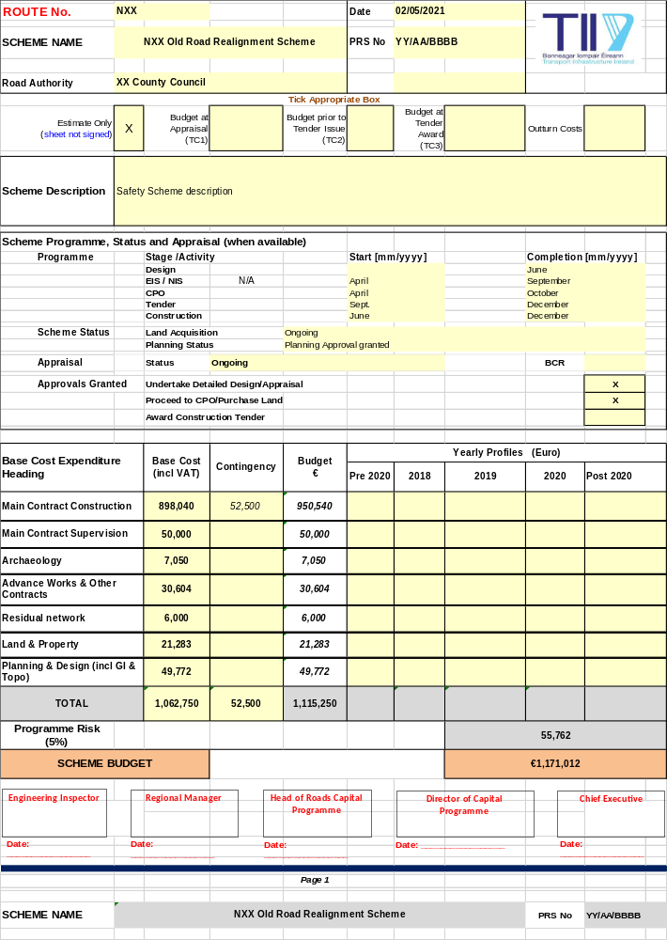
Please see the Supplementary Documents section of the TII Publications website for work sheets PE-PAG-02021_Unit-6.2-Attachments.zip that may be used.]

Appendix B – TII High Collision Locations / Road Safety Inspections

Appendix C - Drawings



